[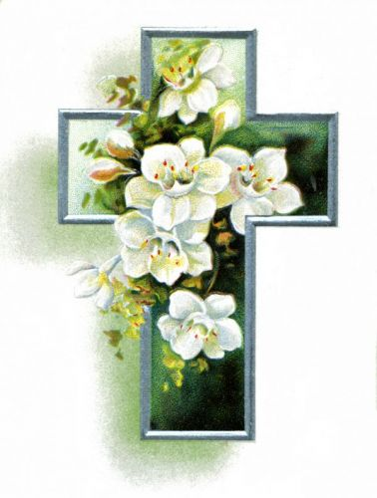](http://www.google.com/url?sa=i&rct=j&q=&esrc=s&frm=1&source=images&cd=&cad=rja&docid=Ote3efIi3nOg_M&tbnid=MJMcvgsW5r_AhM:&ved=0CAUQjRw&url=http://christianimagesource.com/easter_flowers_g282-easter_flowers__image_9_p1785.html&ei=OvssUZiTL-LH0QGViICwDg&bvm=bv.42965579,d.dmQ&psig=AFQjCNEAFqB00waHHg23GoWy5gAy8eT9Yw&ust=1361988758139519)

As in years past we are asking for your help in defraying the increasing cost of our

Easter Flowers and Decorations.

Your kind generosity has always enabled

us to have our church beautifully

decorated for Easter.

Listed below are the suggested donations.

Please return this form together with your donation in the weekly collection or by mail to the Parish Office.

**Please enter your quantity**

**and total your donation.**

**Please print clearly.**

Hydrangeas: $35.00 ________

Easter Lilies (Small): $25.00 ________

Easter Lilies (Large): $35.00 ________

Spring Flowers: $20.00 ________

Total Gift Enclosed: $ ________________

Your Name:

_________________________________________________

In Loving Memory of:

_________________________________________________

_________________________________________________